Scope of Works

Scope of Works 1
Project Overview 2
Deliverables 2
1. System Development & Hosting Strategy 2
2. Data Migration Protocol 2
3. UAT 2
Timelines 2
Detailed Tasks 3
Add client: 3
Client page: 4
Edit Client 6
Client Report: 7
Search For Policy ( BOTH from the client and from the main menu): 8
Search for a client: 10
Apply CAR Policy: 11
View/Edit CAR Policy: 15
Adjustment: 17
CAR Policy Report: 18
CAR Renewal Report: 19
AR Broker Management 20
Migration: 21
Exclusions 22
Payments 22

Project Overview
This Scope of Work is entered into on 15/06/2026 by and between Yongkie Santoso (ABN 19224207570) NSW 2567 and IRECON Insurance Solutions Ltd (ABN 28 142 420 997) PO Box 154, Camden NSW 2570.
This is a fixed-price project that will launch the new IRECON web IT system into production. The scope includes migrating all existing data and transitioning the current functionalities from the legacy EBS platform.

Deliverables

1. System Development & Hosting Strategy
We will develop the IRECON web IT system from the ground up, identifying the optimal hosting architecture and deployment framework. While initial hosting setup costs are included in this fixed-price contract, ongoing production hosting fees will be managed and paid directly by IRECON. The infrastructure will feature two distinct environments: a User Acceptance Testing (UAT) site and a live Production site.

2. Data Migration Protocol
To facilitate data migration, we will provide a comprehensive list of clients holding policies incepted within the last 15 months. IRECON will review this list and flag the specific client records to be migrated into the new system.

3. UAT
We will carry out unit testing for all functionalities. IRECON will conduct a User Acceptance Test and give the final approval.

Timelines
We estimate that it will take between 4 – 6 weeks of working days to complete.

Detailed Tasks
These pages originate from the legacy EBS system. We will replicate all existing functionalities on a like-for-like basis, while simultaneously modernizing the user interface to align with current industry design standards. Additionally, we will maintain a robust security posture by ensuring all software, frameworks, and protocols are fully up to date at the time of deployment.

Add client:
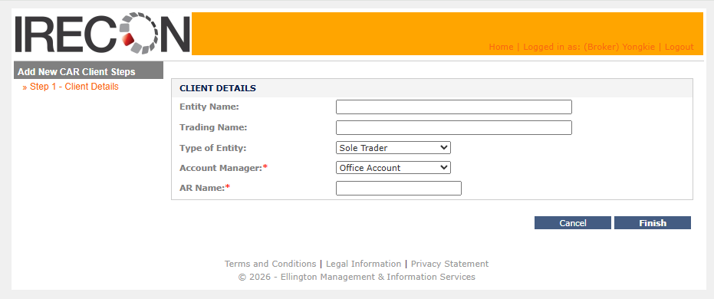
Change Entity Name to Name.
Change to the AR Name selection:
- Typing in the AR name will show the possible list to be selected.
- As part of the AR name, the box should also show the company/practice name.
- The search should only search the first name and last name, it will not search based on company/practice name.

Client page:
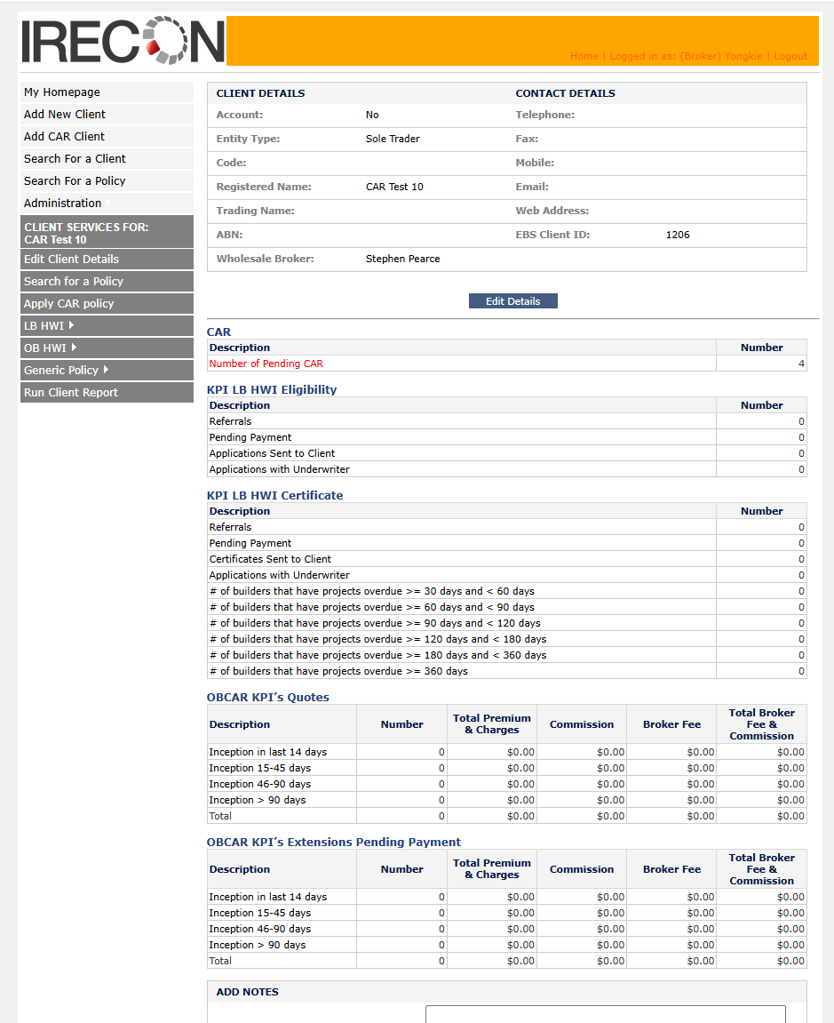
- Client details
  - This page will show all of the information concerning the selected client
  - Insert more information for the AR:
    - AR Company Name
    - AR Contact Name
    - AR Number
    - AR Email
- Policy information
  - There should be a display for: Number of CAR policies
    - PENDING - #
    - Taken - #
    - Not taken - #
      - These should be a link to a policy list. And the list should be linked to the policy view page.
- The new menu will look similar.

Edit Client
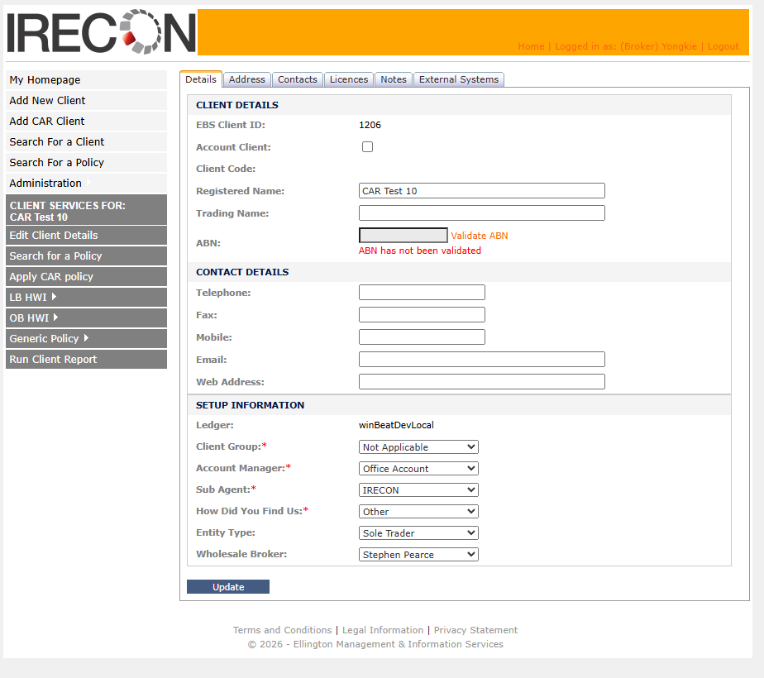
We will only have the fields that are selected from the “Add Client” page. All the other fields will not be migrated.
Note that you are unable to delete any client as part of this release.

Client Report:
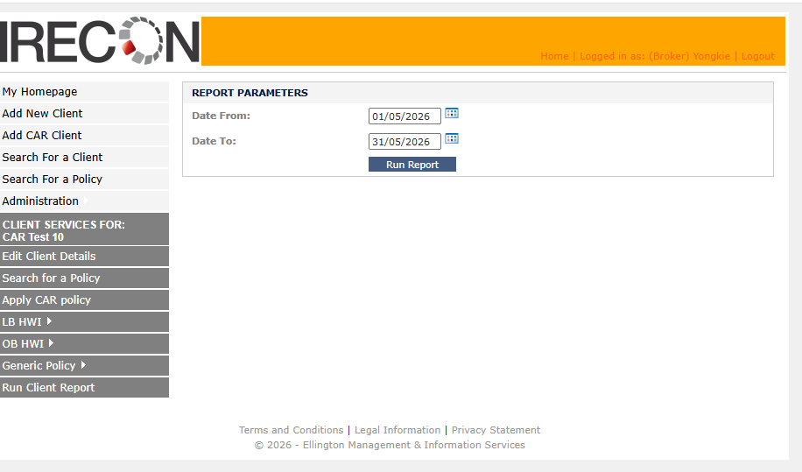
This report is specific to a client. It is a summary of true base premium for all policies belong to the client within the date parameters – including broker fees.

Search For Policy ( BOTH from the client and from the main menu):
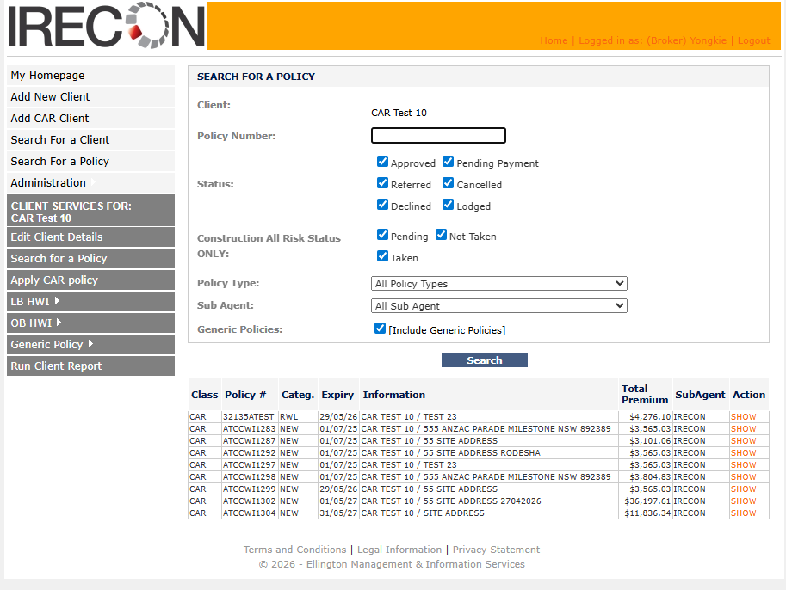
This is the search policy from the client page.
Remove:
- Status
- policy type
- sub agent
- generic policies
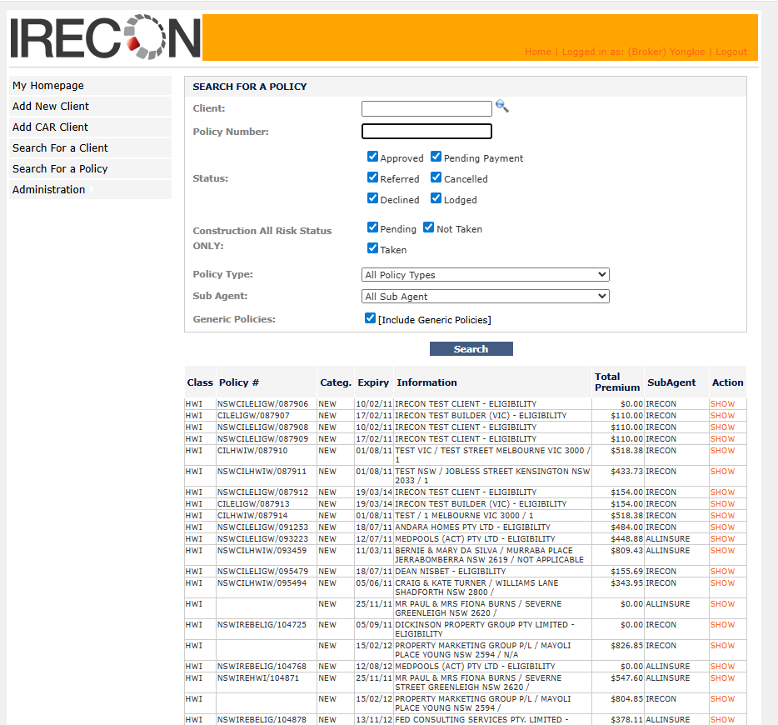
This is the search policy page from the top menu. The change should reflect the search policy page from the client menu.

Search for a client:
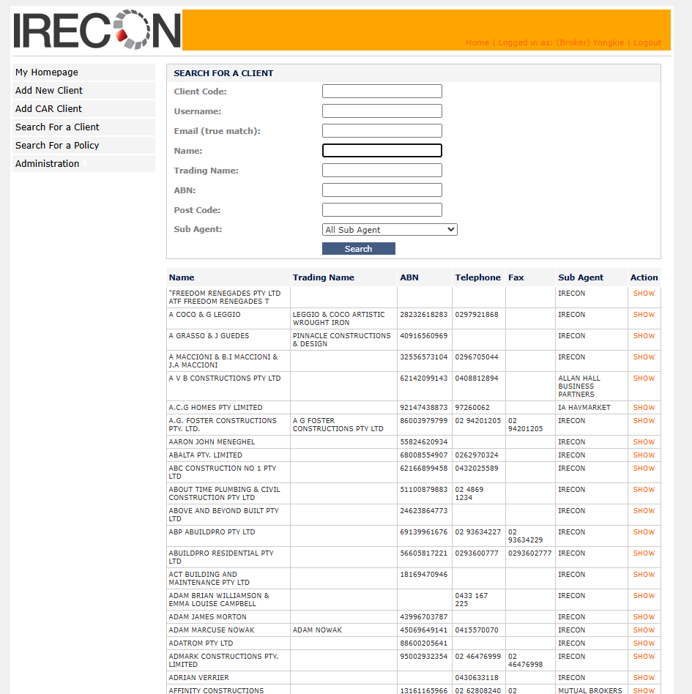
The search fields will be the same as adding client fields:
- Name
- Trading Name
- Account Manager
- AR Company – This list will filter the AR Name
- AR Name – if AR Company is filled in, the list of AR Name should be filtered based on the AR Company.
If empty, then by default, it will select all. The textbox should focus on Name when first load.

Apply CAR Policy:
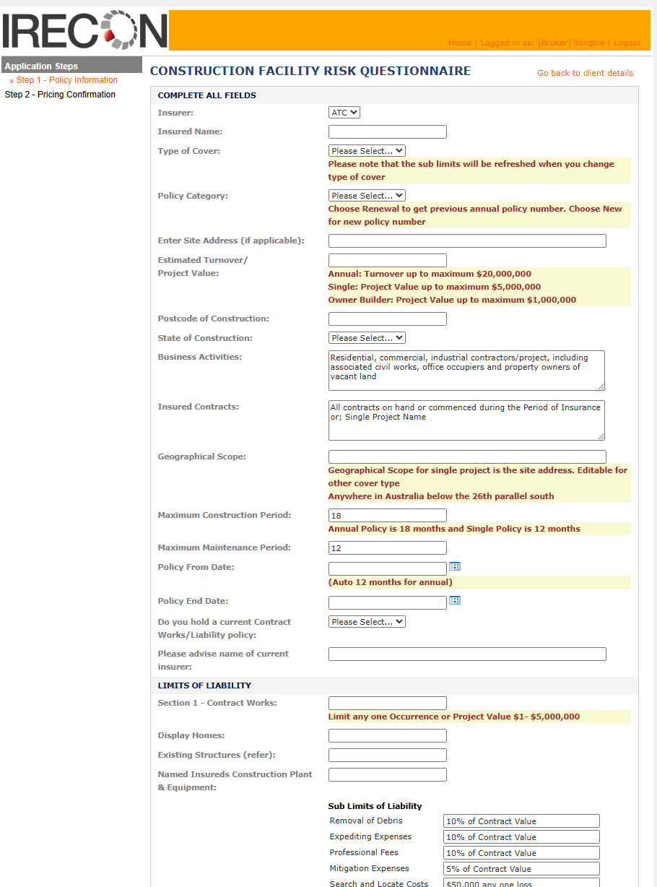
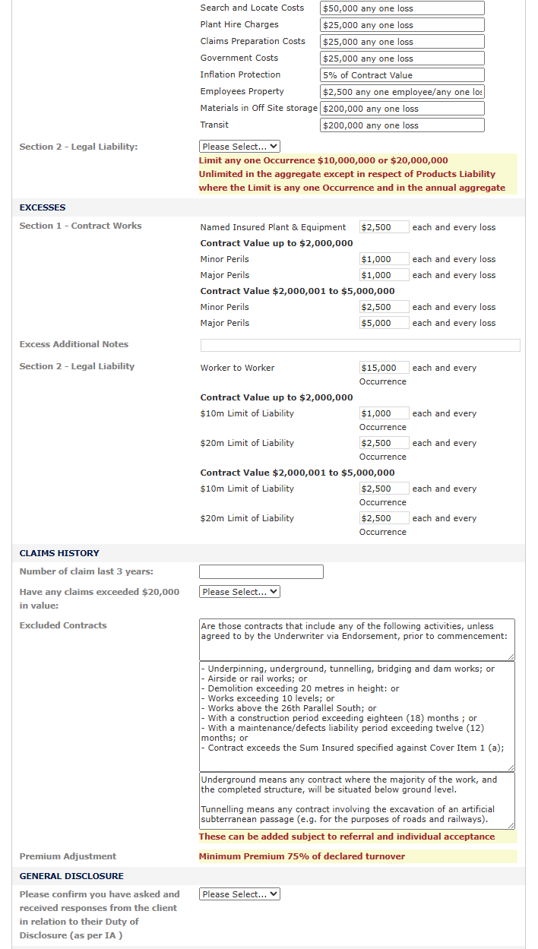
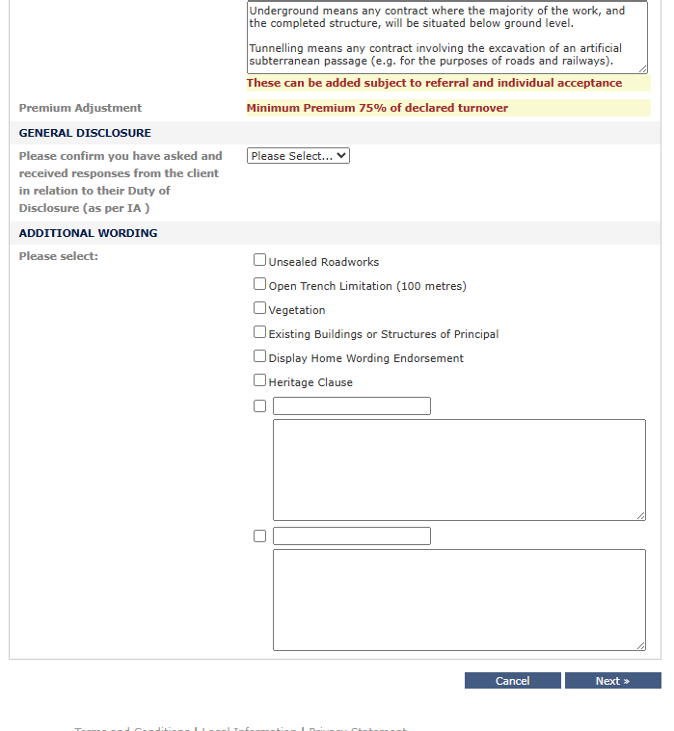

Couple of changes:
- 1. A new question "type of cover". It will only show If this is annual policy. The value will change the text value in “insured contracts”. It should have 2 data:
  - If we select the value "Transfer", then the insured contracts will change to: ""
  - If we select the value "Contract Commencing", then the insured contracts textbox will change to ""
- Waiting for wording from Lesley
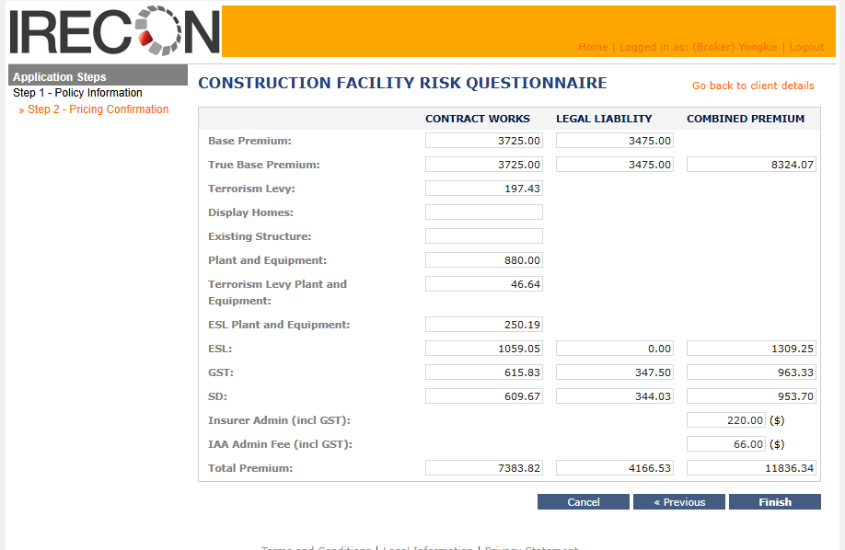
This remains the same.

View/Edit CAR Policy:
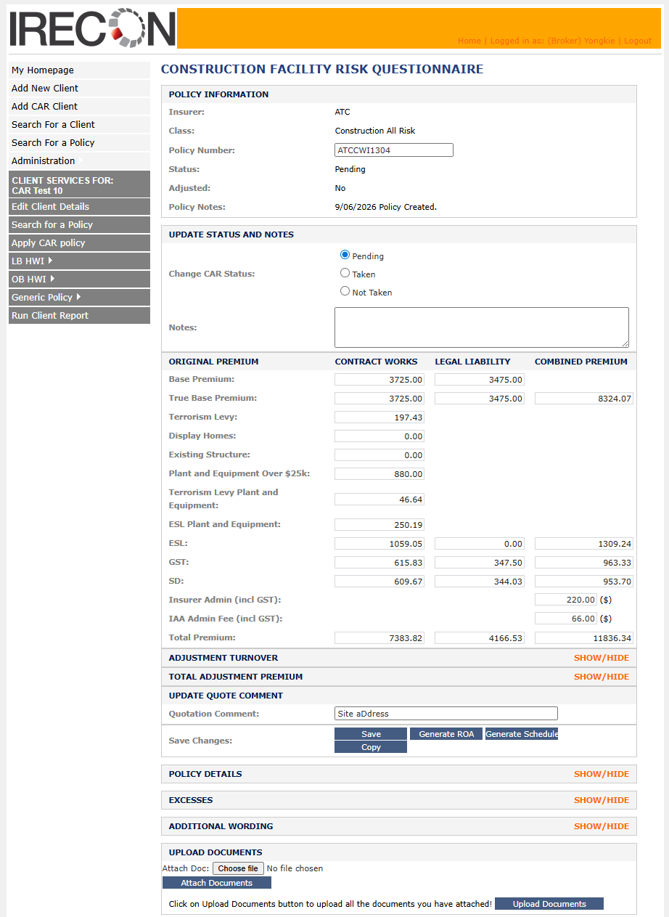
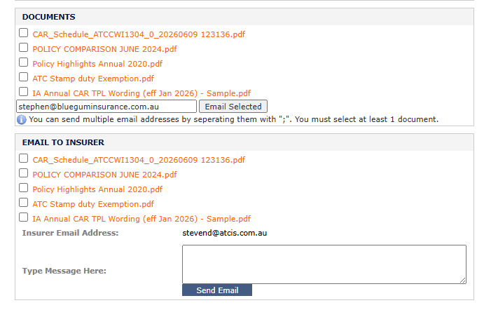
1 Change:
- The inception and expiry date should be put at the top.
- This will be editable until the status is taken/not taken

Adjustment:
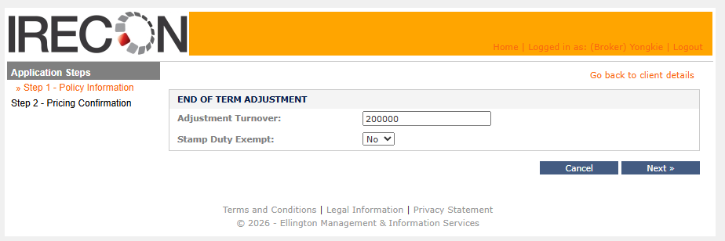
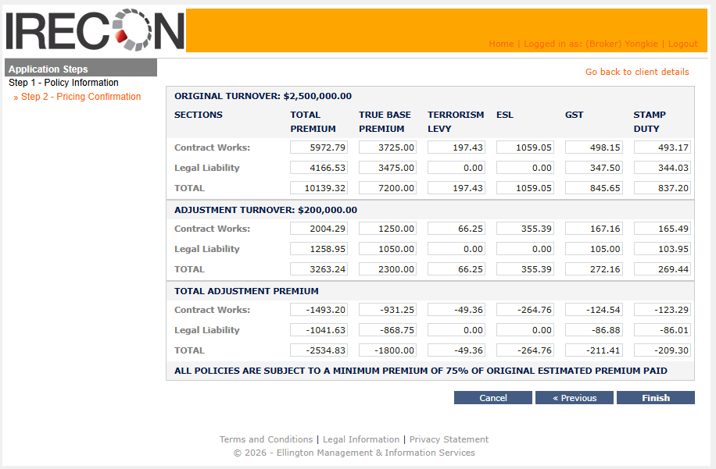
This remains.

CAR Policy Report:
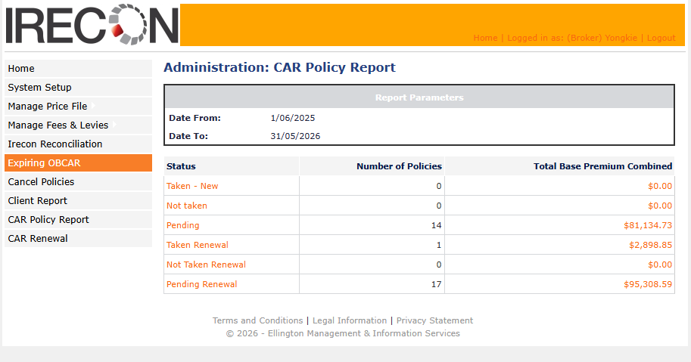
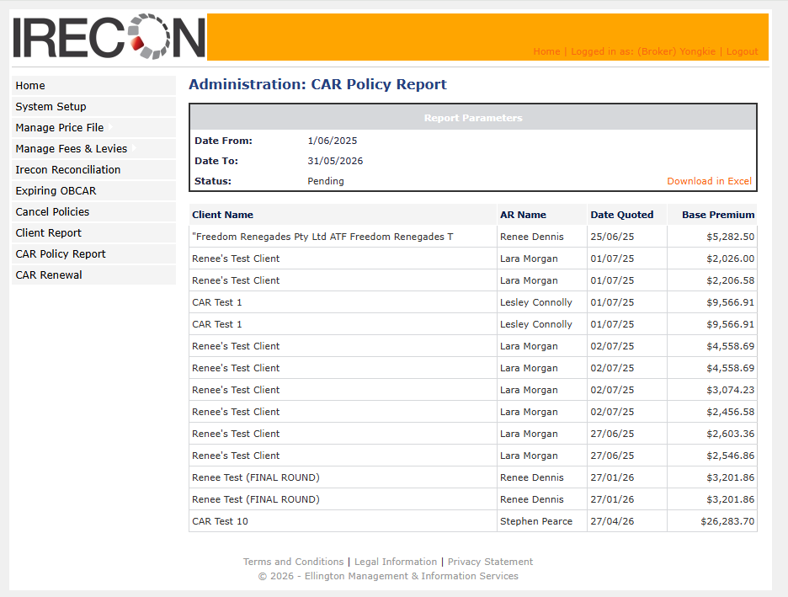
This remains.

CAR Renewal Report:
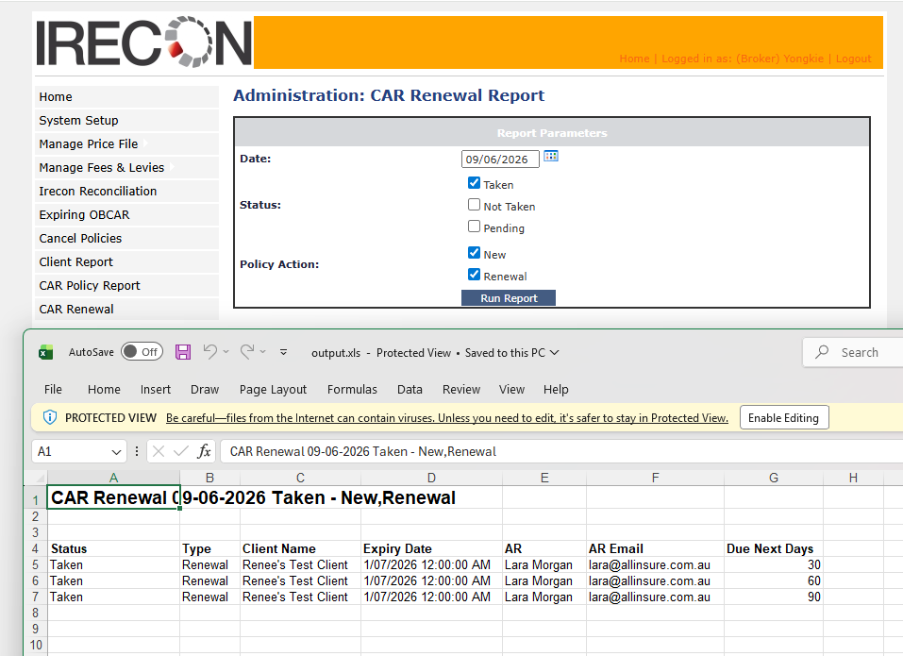
This remains.

AR Broker Management
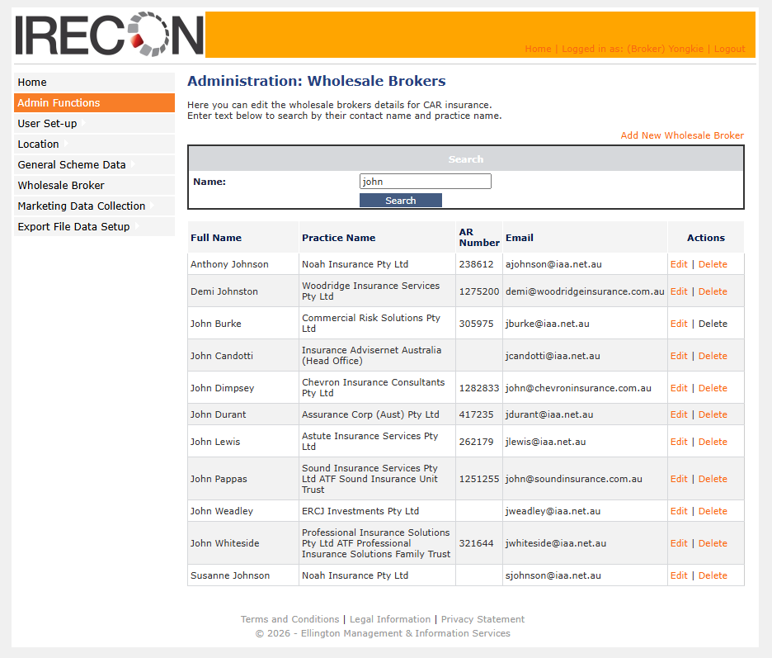
The ability to search, view, edit and delete the AR (which is called Wholesale Broker in EBS).
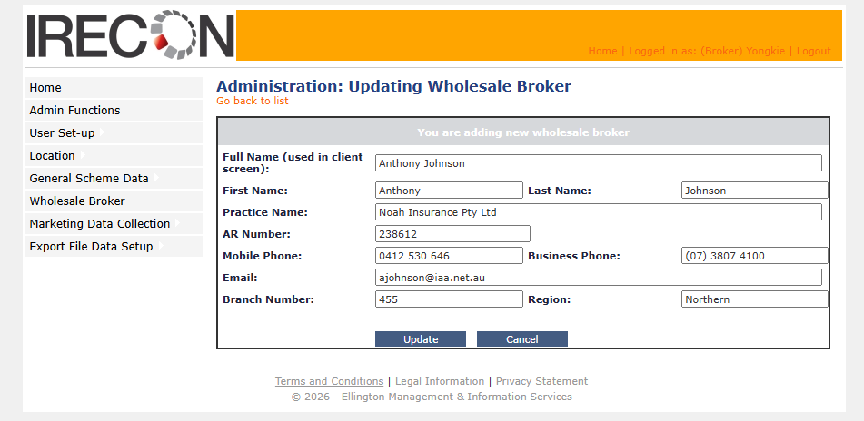

Migration:
To facilitate data migration, we will provide a comprehensive list of clients with their policies incepted within the last 15 months. IRECON will review this list and flag the specific client records to be migrated into the new system.

Exclusions
The project will only cover the following modules:
- Client
- CAR Policy
- Admin function: Managing AR.
Any other works not listed in this document will not be developed.

Payments
This is a fixed price contract of $40,000.00. A deposit of $20,000.00 will be required prior to any work commencing. The remainder will be payable upon the release to production.

